DATA608 Knowledge and Visual Analytics (001)
Daniel Craig
10/23/23

Executive Summary

Topic: Variation in Data Practitioner Salary by Role and State

Target Questions:
1. What variation in average salary for Data Practitioner jobs exists by role and state

Table of Contents
Executive Summary 1
Topic: Variation in Data Practitioner Salary by Role and State 1
Target Questions: 1
Context 2

Context
Roles and sub-fields within data science are rapidly expanding with notable differences in pay and responsibility. Using the Bureau of Labor Statistics, Ziprecruiter, and Salary.com for average salaries by state and role combined with Wisevoter’s Cost of Living Index, the goal is to understand the variance between salaries across role and state.
Story
Salaries across the board range from $40,000 - $160,000+ with little to only moderate at best correlation between salaries and cost of living by role. Viewing distribution and cost of living explains variations.

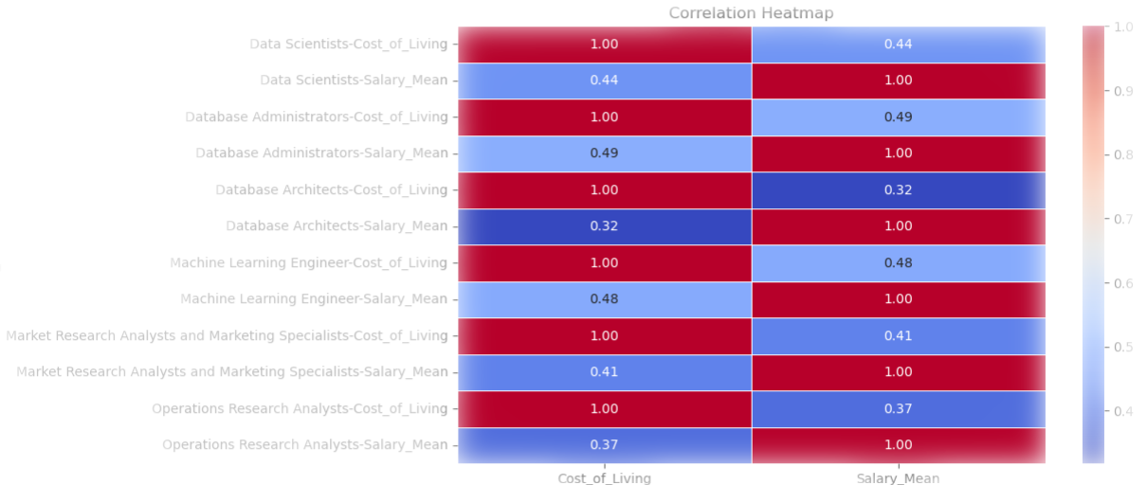
Cost of Living Has Moderate to Weak Impact
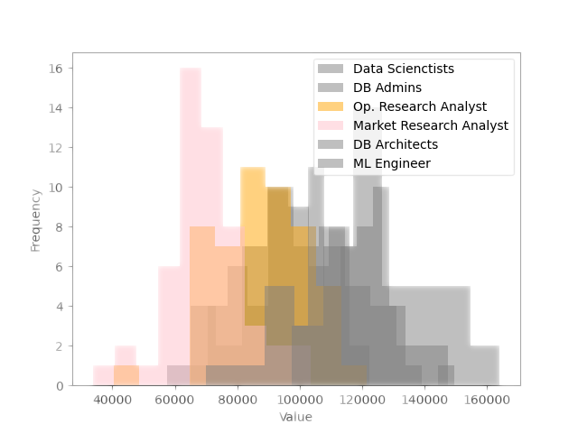
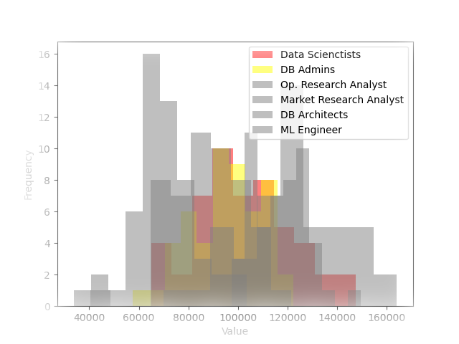
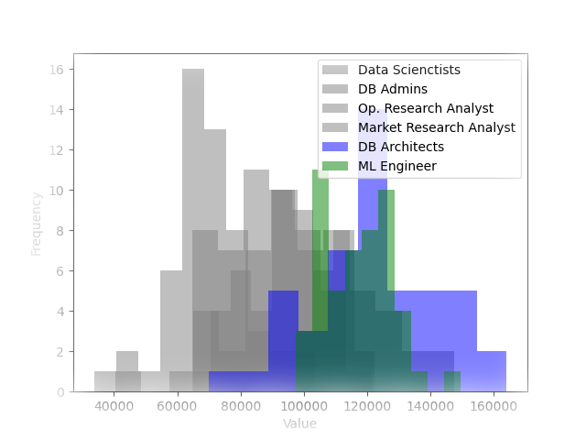
Scientists and Admins Center the Pack
Business Analysts Cover the Rear
Architects and Engineers Lead

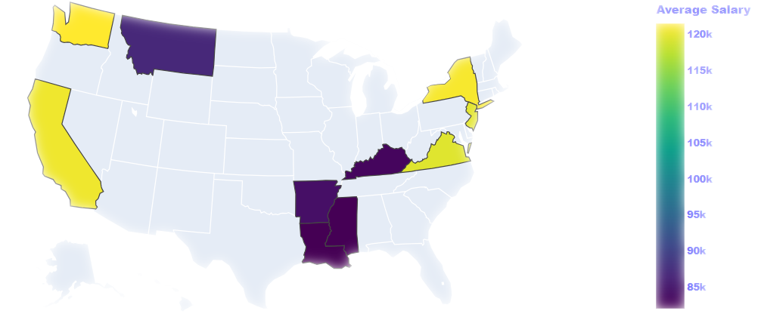
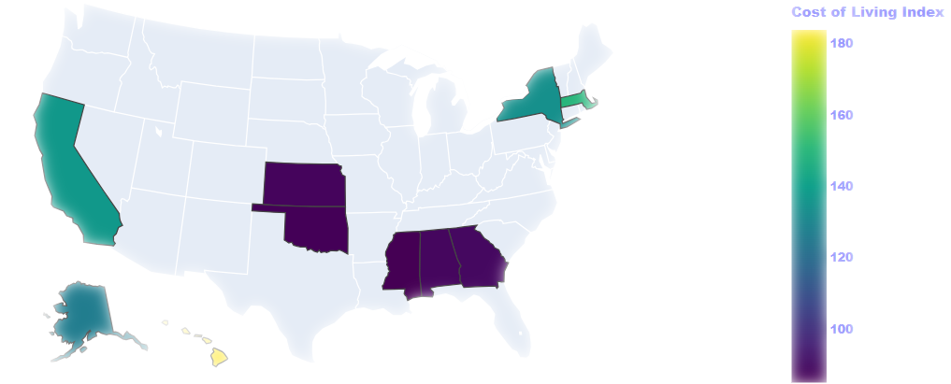
West and NE Lead Average Salary
West and NE Lead Cost of Living

References/Code Appendix:
“Bureau of Labor Statistics.” Bureau of Labor Statistics, Oct. 2023, https://www.bls.gov/.
“Cost of Living by State 2023 - Wisevoter.” Wisevoter, 2023, https://wisevoter.com/state-rankings/cost-of-living-by-state/#cost-of-living-index.
“Data Architect Salary | Salary.Com.” Salary.Com, Oct. 2023, https://www.salary.com/research/salary/listing/data-architect-salary.
“What Is Machine Learning Engineer Salary by State?” ZipRecruiter, Oct. 2023, https://www.ziprecruiter.com/Salaries/What-Is-the-Average-Machine-Learning-Engineer-Salary-by-State.
https://github.com/CUNY-SPS-Data-Science-Program/your-bio-d-ev-craig/blob/main/Major%20Assignments/Story%204/Story_4_DCraig.ipynb

